**DAILY ONLINE ACTIVITIES SUMMARY**

|  |  |  |  |  |  |  |  |  |
| --- | --- | --- | --- | --- | --- | --- | --- | --- |
| **Date:** | **21/05/2020** | | | | | **Name:** | **AKASH S** | |
| **Sem & Sec** | **4TH&A** | | | | | **USN:** | **4AL18CS004** | |
| **Online Test Summary** | | | | | | | | |
| **Subject** | | **MICRO CONTROLLER AND EMBEDED SYSTEMS** | | | | | | |
| **Max. Marks** | | **30** | | **Score** | | | **23** | |
| **Certification Course Summary** | | | | | | | | |
| **Course** | **PYTHON FOR MACHINE LEARNING** | | | | | | | |
| **Certificate Provider** | | | **GREATLEARNING** | | **Duration** | | | **5 HOURS** |
| **Coding Challenges** | | | | | | | | |
| **Problem Statement:1: 1.Write a c program to create singly linked list(SLL) with n elements and reverse the element using c.**  **Problem Statement 2: . Write a C program to construct a singly linked list by removing duplicate elements in the sorted linked list**  **Problem Statement 3: . Write a C program to implement SRTF process scheduling.** | | | | | | | | |
| **Status: executed** | | | | | | | | |
| **Uploaded the report in Github** | | | | | **YES** | | | |
| **If yes Repository name** | | | | | [**https://github.com/akashacharya786/lockdown-c-coding**](https://github.com/akashacharya786/lockdown-c-coding) | | | |
| **Uploaded the report in slack** | | | | | **YES** | | | |

Online Test Summary:

18CS44 the test was from 1st module which was about Architectural features and instruction of harm micro controller . There are 30 questions and the duration 40minutes.The score that I received was 23/30.

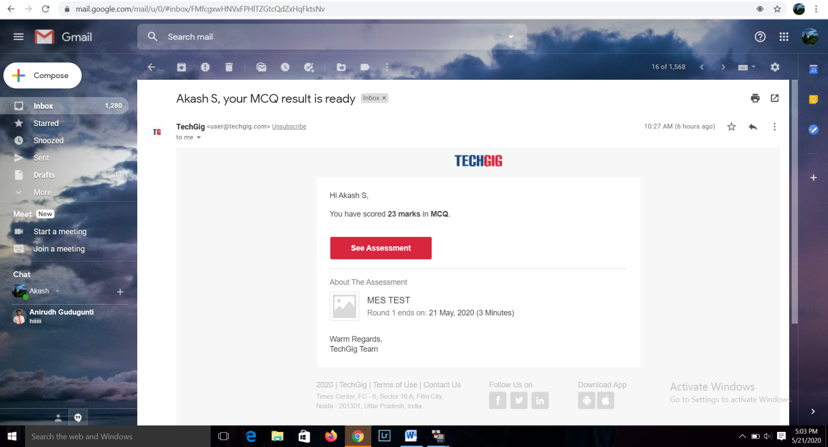

Online Certification course:

Name of the course: Python for machine learning.

In the 4TH day I learnt the introduction of pandas and its functions. Basically panda is package used for the managing data. The main purpose of panda is that it creates two new data types for storing the data.

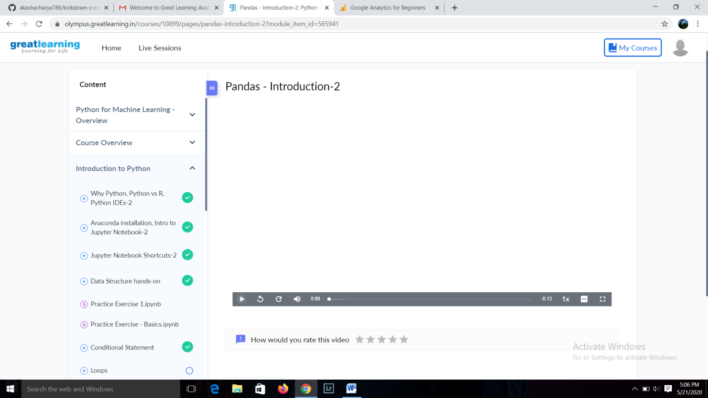

This the snapshot of online course

Online Coding summary:

1.Write a c program to create singly linked list(SLL) with n elements and reverse the element using c.

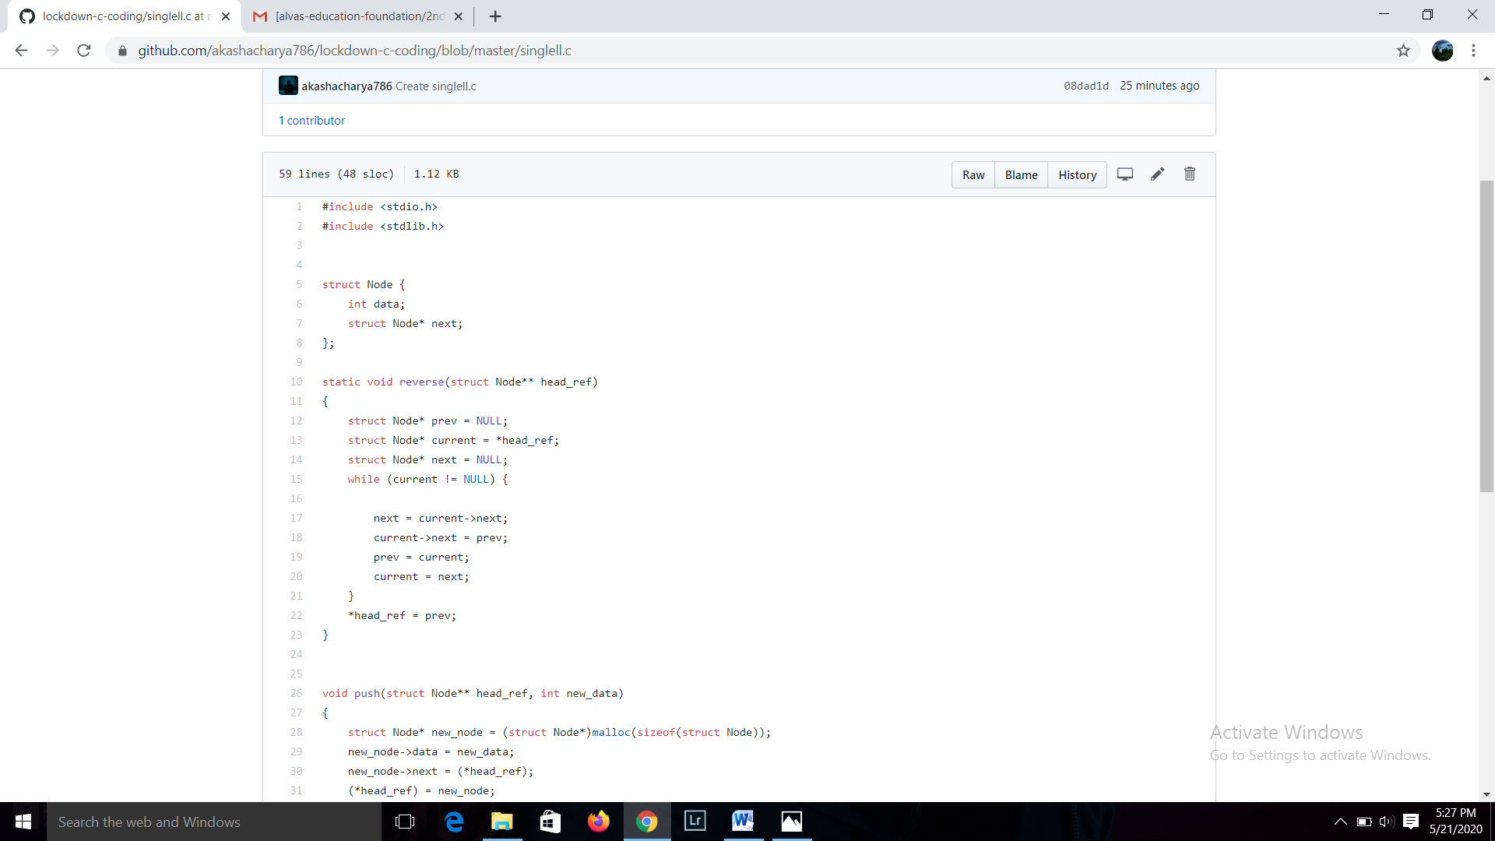

2. Write a C program to construct a singly linked list by removing duplicate elements in the sorted linked list  
Description:  
Take a sorted list and traverse the list. Compare the current node element with next adjacent node. If it is same then delete second element, if not retain. Finally print the resulting list.  
Sample output:  
Given list {1,2,2,3,3,3,4}  
Resulting list{1,2,3,4}

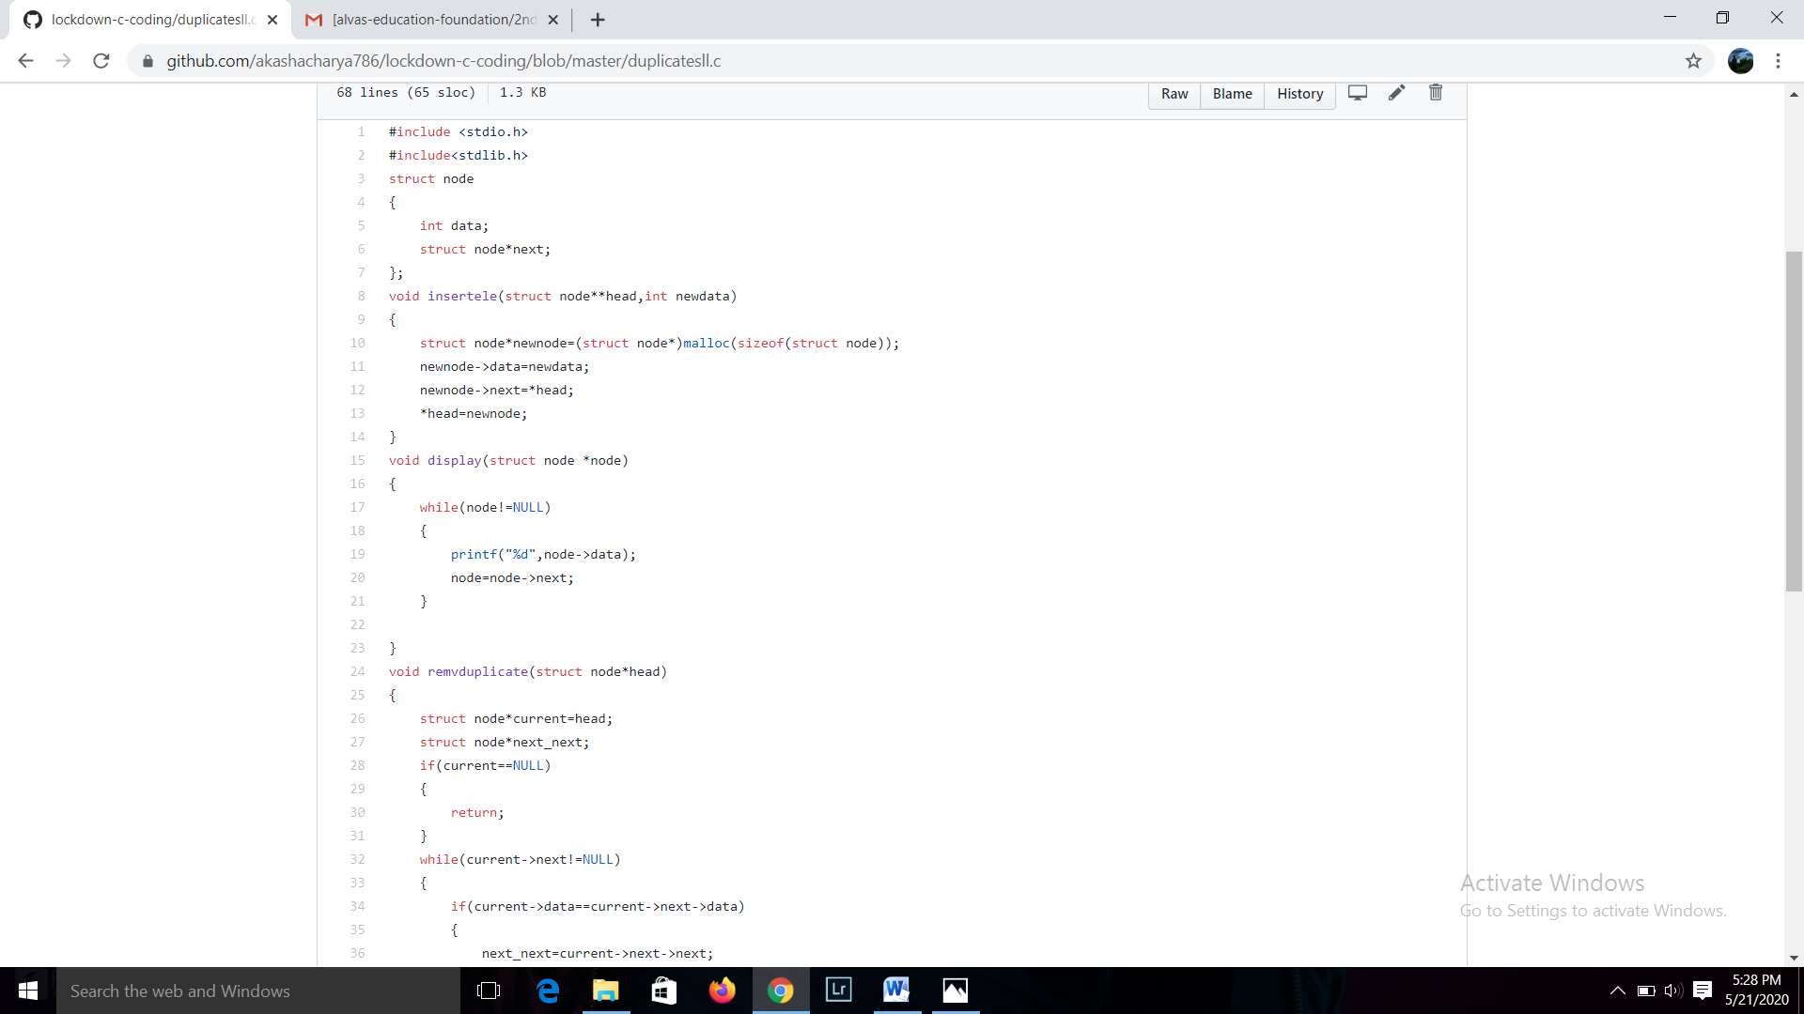

3. Write a C program to implement SRTF process scheduling.  
Input: A set of processes with their burst time and arrival time  
Output: The processes scheduled based on the arrival time and a smaller burst time.

